Computer Graphics, Lab Assignment 1
Handed out: March 15, 2026
Recommended due: 15:00, March 23, 2026
Hard due: 23:59, March 23, 2026 (NO SCORE for late submissions!)
Submit your assignment only through the lecture home at portal.hanyang.ac.kr.

- This assignment aims to make you set up a Python environment and practice submitting an assignment. To do this,
  - Install Python, NumPy, PyOpenGL, glfw as instructed in the Lab1-EnvSetting slides.
  - Start the python interpreter in the interactive mode and import numpy, OpenGL, glfw and print the version of those modules and capture the screenshot. Refer the example screenshot 2022xxxxxx.jpg below.
  - You can use Windows command prompt or Linux/Mac terminal or something like that to run Python interpreter in interactive mode.
  - Submit a single image file (#1) and a python file (#2) zipped into a single zip file - [studentID]-[assignment#]-[prob#].zip (e.g. 2024123456-1-1.jpg and 2024123456-1-2.py)
      - Example screenshot: 2024xxxxxx.jpg (or .png) (Versions are not important)
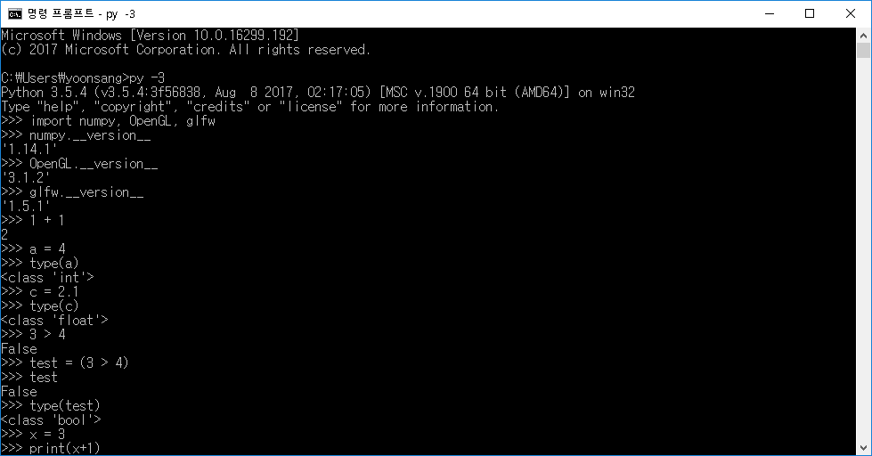

- Write down a Python program to:
  - Create a 1d array M with values ranging from 2 to 26 and print M.
  - Reshape M as a 5x5 matrix and print M.
  - Set the value of “inner” elements of the matrix M to 0 and print M.
  - Assign M² to the M and print M.
  - Let’s call the first row of the matrix M a vector v. Calculate the magnitude of the vector v and print it.
    - Hint: 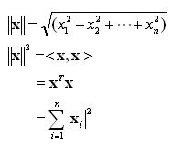
    - Hint: Use np.sqrt()
  - Include a single .py file - [studentID]-[assignment#]-[prob#].py (e.g. 2024123456-1-2.py) in the zip file.
Expected output: (Output format doesn’t have to an exact match.)
[ 2 3 4 5 6 7 8 9 10 11 12 13 14 15 16 17 18 19 20 21 22 23 24 25 26]

[[ 2 3 4 5 6]
[ 7 8 9 10 11]
[12 13 14 15 16]
[17 18 19 20 21]
[22 23 24 25 26]]

[[ 2 3 4 5 6]
[ 7 0 0 0 11]
[12 0 0 0 16]
[17 0 0 0 21]
[22 23 24 25 26]]

[[ 290 144 152 160 370]
[ 256 274 292 310 328]
[ 376 404 432 460 488]
[ 496 534 572 610 648]
[1490 664 712 760 1970]]

538.924855615326

